[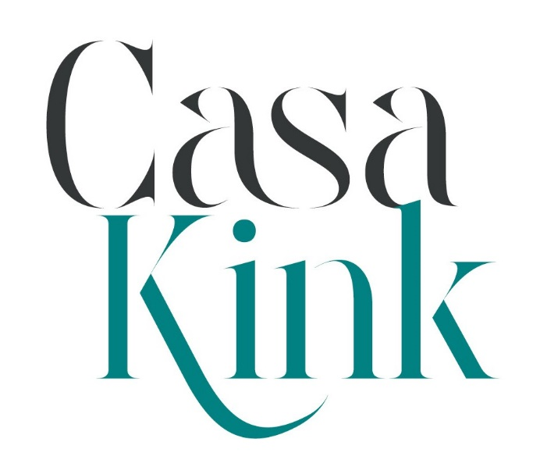](https://hostsandhomes.com)

Welcome to Casa Kink Dungeon

This document covers the terms and conditions of renting Casa Kink Dungeon.

Address:

Unit 1

4 Engine Ave

Montague Gardens

Our building has a sign saying **Business Hub**. There are no Casa Kink signs.

If you have any questions about the space, please contact us on WhatsApp on **079 396 9012.**

Please make yourselves at home! Have a look through the cupboards to familiarize yourself with the contents of the property. The property should be spotless with clean bedding on the beds as well as clean glasses, coffee, tea etc.

If you find anything to not be to your satisfaction, please inform us within the first few hours of arriving at the property to provide us with an opportunity to resolve the issue.

Contents

Arrival 3

Privacy 3

Arrival Procedures 3

Lights and Power 3

Serving 4

Toilets 4

Outdoors and Smoking 4

Parking 4

Temperature Control 5

Trash 5

Emergency Information 5

First Aid 5

Fire Hydrants 5

Emergency Contacts 5

Returning the Dungeon as You Found it 6

Cleaning 7

Furniture Moving 7

Departure 7

# Arrival

## Privacy

Please note there are cameras on the outside of our building for security reasons. Please feel free to cover your face on entry. Once inside our building there are NO cameras.

## Lights and Power

Lights for the social area, kitchen and passage are on the wall in the passage (walk directly through reception), they are on the left hand side after the door.

To the left of the lights is the Fuckle Puddle which has 2 typical switches on the wall inside. In addition there are LEDs (switched on behind the couch).

In the Social Area there is a single lamp for more subtle lighting.

From the passage you will see double doors which lead into the Dungeon, these are most often open. As you walk through into the Dungeon, into the first area (called Open Dungeon) the light switch is on the wall on the left-hand side as you go through the doors.

On the bar counters in the Social Dungeon is a lamp, you can switch it on, on the lamp.

On the wall opposite, to the left of the wide entrance to the Covered Dungeon are the light switches (hidden behind the fabric, if you separate the teal from the black fabric, you will see the light switch). This covers the Covered Dungeon (the one with the 2 x St Andrews Crosses and large mirrors).

The first room off the Covered Dungeon is the (Chamber). There is a restraint table and cage. At the back of this room, on the wall you can switch on the lights which include the stair lighting, massage and St Andrew’s lighting, light bar in Social Dungeon as well as a standing lamp and desk lap in the Chamber.

The second room is the Boudoir. Electricity runs into this space from a plug point under the toy display in the Covered Dungeon (next to the disabled toilet). There are 2 lamps. This switch also powers the light in the wheelchair accessible toilet.

Further to the right, almost at the end of that wall before the electrics unit which is behind a curtain you’ll find another plug point. You’ll know it’s the right one because it will power the lamp on the cabinet next to it. This powers all the rest of the lights, including a lamp on 2 of the cabinets in the room, the uplighters and the sound system which is near the industrial doors in the Social Dungeon.

Upstairs on the landing you’ll find the overhead lights for the first two rooms. The landing room has a lamp on the floor. The second room has the pillory and 2 x double mattresses, there are two mannequin lamps on the floor. The last room is the Hide Away, there are bedside lamps in this space.

## Serving

Please feel free to rummage through the kitchen, you will find an array of bowls and serving platters. The chest freezer will typically have a few bags of ice and the fridge will have milk (can find extra in the kitchen cupboards). Please note there are no cooking facilities.

Glasses are typically laid out on the bar counters, along with water jugs, and ice buckets. On the passage serving cupboard you’ll find some mugs, tea, coffee etc.

## Toilets

There are 5 toilets in cubicles and one urinal. All our bathrooms are for all genders. The toilet in the Covered Dungeon is wheelchair accessible.

## Outdoors and Smoking

You can open the large industrial doors in the open dungeon, there is a gate which can be locked closed providing security and natural light. The key is in the padlock on this door. If facing the industrial doors, to the right you will find a folding table, chairs and outdoor heaters (please DO NOT use the tall heaters indoors).

Outside we have a picnic bench under cover for use when smoking. There is also a table and 6 metal chairs in the Social Dungeon which can be used outdoors. Ashtrays and a bong can be found on top of the fridge.

Absolutely no smoking at all inside the building, that includes vapes.

## Parking

There is off-street parking for 2-4 vehicles during the day and around 20 at night. Once this is full, there is plenty of parking outside. Please stay off driveways, even at night as some businesses in the area have odd hours deliveries.

## Temperature Control

There are indoor (short) and outdoor (tall) gas heaters. Please do NOT use the tall heaters indoors.

If it is cold we advise keeping the industrial doors closed and only using the reception entrance and exit, including for smoking.

We have a few fans for the hot weather and an aircon in the Fuckle Puddle. Please do not use the aircon or fans during power outages, while we have power backup it cannot cope with high draw.

## Trash

Please make use of the dustbins provided around the Dungeon. If you have not made use of our cleaning service, please empty your dustbins in the large dustbin in the kitchen and then empty the kitchen dustbin bags into the outdoor bin. It stands on the other side of our car port.

Unfortunately, we do not have recycling facilities.

# Emergency Information

## First Aid

There are three first aid kits distributed around the Dungeon. One outside the Social Area in the passage. One in the Covered Dungeon outside the Chamber and one at the top of the stairs. They are hung on walls and easy to identify by the red bag with a white cross.

## Fire Hydrants

There are several Fire Hydrants, distributed around the Dungeon with clear signage, including to the exits.

## Emergency Contacts

If you have an emergency, please contact us by calling **079 396 9012**. Please note we may not respond quickly so contact the appropriate emergency service if needed.

* Milnerton MediClinic 117 Racecourse Road – **0861224555**
  + Emergency **084124**
* Police / Flying Squad **10111**
* Ambulance **10177**
* Fire and Rescue **021 590 1900**

# Returning the Dungeon as You Found it

You are welcome to move furniture around to suit your event, but please ensure to return all items to the correct space. In order to make this easier we have an inventory room by room and have labelled boxes for each space should you wish to pack items away for your event. That way when you return things you are clear on their homes.

If you have taken a standard rental please complete all items in the above table under the “Standard Rental” column etc.

You will be liable for any damage to furniture as a result of moving it from its original location.

When returning the space please ensure you have completed all items in the list below in order to ensure you have returned the Dungeon ready for the next people to arrive.

| **Standard Rental** | **Cleaning Service** | **Furniture Moving Service** | **Cleaning and Furniture Moving Services** |
| --- | --- | --- | --- |
| **ALL** Furniture is to be put back where it was originally, see the attached inventory if you need assistance. | **ALL** Furniture is to be put back where it was originally, see the attached inventory if you need assistance. | Furniture movement service includes this. | Furniture movement service includes this. |
| Replace all signage | Replace all signage | Replace all signage | Replace all signage |
| Replace all art including backdrops | Replace all art including backdrops | Replace all art including backdrops | Replace all art including backdrops |
| Replace all electricals (extension leads, multiplugs, lamps and adapters) | Replace all electricals (extension leads, multiplugs, lamps and adapters) | Replace all electricals (extension leads, multiplugs, lamps and adapters) | Replace all electricals (extension leads, multiplugs, lamps and adapters) |
| Return the Sound System on top of its cabinet in the Social Dungeon, near the Industrial doors. | Return the Sound System on top of its cabinet in the Social Dungeon, near the Industrial doors. | Return the Sound System on top of its cabinet in the Social Dungeon, near the Industrial doors. | Return the Sound System on top of its cabinet in the Social Dungeon, near the Industrial doors. |
| Replace all draping including curtains over doorway and ceiling draping | Replace all draping including curtains over doorway and ceiling draping | Replace all draping including curtains over doorway and ceiling draping | Replace all draping including curtains over doorway and ceiling draping |
| Clean the furniture with the supplied spray and cloth | Cleaning service includes this | Clean the furniture with the supplied spray and cloth | Cleaning service includes this |
| Ropes requiring cleaning should be left in the cabinet on the floor next to the toy display. | Ropes requiring cleaning should be left in the cabinet on the floor next to the toy display. | Ropes requiring cleaning should be left in the cabinet on the floor next to the toy display. | Ropes requiring cleaning should be left in the cabinet on the floor next to the toy display. |
| Strip beds of used linen, place them in the cabinet under the urn in the passage. | Cleaning service includes this | Strip beds of used linen, place them in the cabinet under the urn in the passage. | Cleaning service includes this |
| Put on clean linen if available, most spaces have clean bedding in a basket in the room. If you cannot find any there, you may find in the first cupboard from reception in the passage. | Cleaning service includes this | Put on clean linen if available, most spaces have clean bedding in a basket in the room. If you cannot find any there, you may find in the first cupboard from reception in the passage. | Cleaning service includes this |
| Ensure all condoms are placed in dustbins along with all other rubbish. | Ensure all condoms are placed in dustbins along with all other rubbish. | Ensure all condoms are placed in dustbins along with all other rubbish. | Ensure all condoms are placed in dustbins along with all other rubbish. |
| Take out your rubbish | Cleaning service includes this | Take out your rubbish | Cleaning service includes this |
| Wash your dishes | Cleaning service includes this | Wash your dishes | Cleaning service includes this |
| Ensure floors and surfaces are clean including bar counters. There is a broom /vacuum /mop and cloths in the kitchen. Clean up all mess. | Cleaning service includes this | Ensure floors and surfaces are clean including bar counters. There is a broom /vacuum /mop and cloths in the kitchen. Clean up all mess. | Cleaning service includes this |
| Turn off all the lights | Turn off all the lights | Turn off all the lights | Turn off all the lights |

## Cleaning

If you are making use of Casa Kink cleaning, this is at a charge of R400 per day. Typically, the Dungeon can be cleaned after a party of around 120 people, in one day. Please note that if this cleaning takes place on a Public Holiday the rate is R800. If we are doing the cleaning, you are still responsible for ALL items listed under the Cleaning Service list.

## Furniture Moving

If you require us to return the furniture to its place, this will be a total of R800 for cleaning and moving furniture to allow for 2 people to carry furniture back to its place.

If the Dome is up when you use the space you need to return it with the Dome up. If you want us to put the Dome back up, that is an additional R400, over and above cleaning costs and furniture movement.

If on return of the Dungeon the space is not returned to its original state, you will be charged R800 on top of any agreed cleaning fee for us to do this.

Even if you have booked for cleaning and furniture movement you are still responsible for completing all items under the cleaning and furniture moving service column in the table above.

# Departure

* Turn off all lights.
* If you have made use of heaters or fans or aircon, ensure these are turned off.
* Make sure **all** toilet doors are closed (the alarm will not set if this is not done).
* Turn on the alarm.
* Lock the front door, close the first gate (it automatically locks) and close and lock the trellis gate.
* Put the keys back in the keysafe.
* The gate can be opened and then closed behind you with the code.

WE HOPE YOU ENJOY YOUR PLAY WITH US!